DATE: 27.06.22
PROVISIONAL SELECTION LIST 14
CATEGORY SGC
SNO | APPLICATION  SUBMISSION CODE | NAME OF THE STUDENT | SERVICE  CATEGORY | NO OF TRANSFERS | POST LOTTERY SL NO
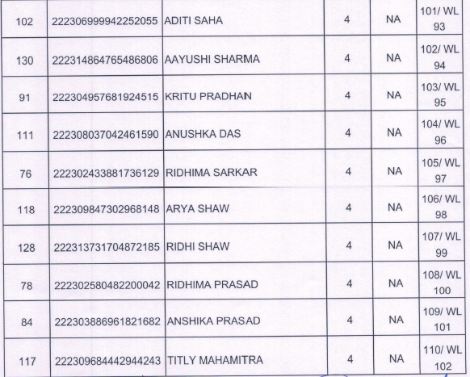
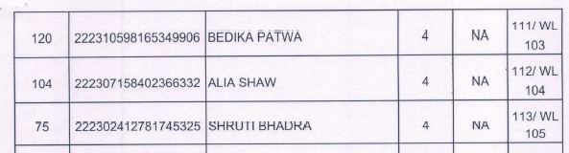

CATEGORY ST

SNO | APPLICATION  SUBMISSION CODE | NAME OF THE STUDENT | SERVICE  CATEGORY | NO OF TRANSFERS | POST LOTTERY SL NO

PRINCIPAL

CATEGORY IV

SNO | APPLICATION  SUBMISSION CODE | NAME OF THE STUDENT | SERVICE  CATEGORY | NO OF TRANSFERS | POST LOTTERY SL NO
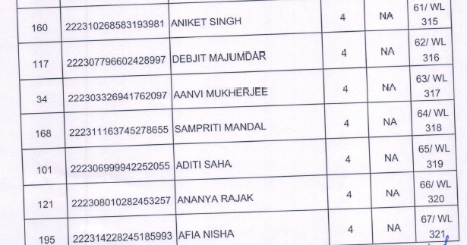
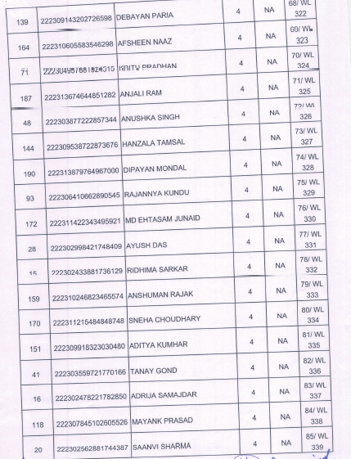

PRINCIPAL
SNO | APPLICATION  SUBMISSION CODE | NAME OF THE STUDENT | SERVICE  CATEGORY | NO OF TRANSFERS | POST LOTTERY SL NO
CATEGORY IV
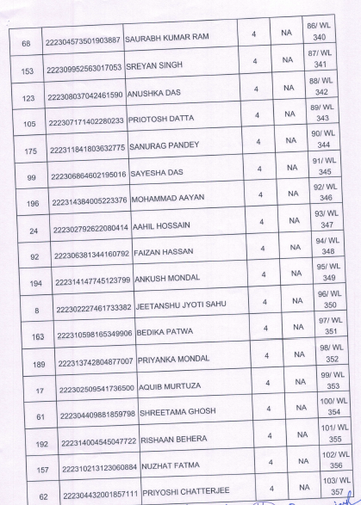

PRINCIPAL

